

**Visvesvaraya Technological University, Belagavi**

**Seminar** **On**

**“INFRARED THERMOGRAPHY”**

**Submitted in partial fulfilment of the requirement for the award of the degree**

**Bachelor of Engineering**

**in**

**ELECTRICAL ENGINEERING**

**Submitted by**

**PREETHU K**

**4GW16EE033**

**Under the guidance of**

**Mr. JAGADISHA N**

**Assistant Professor,**

**Department of Electrical Engineering,**

**GSSSIETW**

-

**MYSORE.**

**Department of Electrical Engineering**

**GSSS Institute of Engineering and**

**Technology for Women, Mysore**

**2019**

**-**

**2020**



Certificate

It is Certified that the Seminar entitled **“INFRARED THERMOGRAPHY”** is a Bonafede work carried out by **PREETHU K, 4GW16EE033,** inpartialfulfilmentofrequirementsfortheawardofBachelorofEngineeringdegreein **ELECTRICAL ENGINEERING** by **VISVESWARAYA TECHNOLOGICAL UNIVERSITY, BELGAUM** duringthe academic year of 2019-2020. It is certified that all corrections and suggestions indicated for the internal assessment have been incorporated in the report deposited in the department library. This seminar report has been approved as it satisfies the academic requirements in respect of seminar work prescribed for the set degree.

.

Signature of the Guide Signature of H.O.D

**Prof. Jagadisha N Dr. Puttaswamy**

Assistant Professor Professor and H.O.D

**Signature of:**

**Examiner 1:** …………………………………

**Examiner 2:** …………………………………

**ABSTRACT**

Infrared thermometers are easy to use and have a quick response time. They are widely used for temperature measurement of the human body; the accuracy and uncertainty of measurement is the importance performance indicator for these meters.

The application of infrared (IR) measurement temperature principles and an infrared thermometer in the testing of a temperature is mainly presented in this. The advantages of IR temperature measurement technique with no destruction of the measured temperature field, quick response and high sensibility are pointed out, which is suited to testing the temperature. Infrared thermometers measure temperature from a distance, using the infrared radiation emitted by all objects. These so-called non-contact thermometers make a wide variety of temperature measurement and monitoring activities accessible to school-age students. The development of infrared temperature measurement is helpful to non-contact, quickly and accurately measurement moving and high temperature objects.

We develop an infrared thermometer for high temperature objects under the premise of high measuring accuracy and low cost. Quick and accurate measurement of the surface temperature for an object was realised.

## LIST OF FIGURES

|  |  |  |  |  |  |
| --- | --- | --- | --- | --- | --- |
| **FIGURE NO.** | | **TITLE** | | **PAGE NO.** | |
| **1.2** | | **ELECTROMAGNETIC RADIATION DIAGRAM.** | | **4** | |
| **1.3** | | **DISTANCE SENSATIONS.** | | **5** | |
| **3.1** | | **RADIATIONS AT DIFFERENT WAVELENGTH.** | | **7** | |
| **3.2** | | **COMPONENTS OF INFRARED THERMOMETER.** | | **8** | |
| **4.3.1** | | **THERMOCOUPLE.** | | **11** | |
| **5.0** | | **SCREENING DISPLAY.** | | **18** | |
| **5.1** | | **THERMOGRAPHIC DIAGRAM.** | | **20** | |
|  | |  | |  | |
|  | |  | |  | |

# INDEX

|  |  |  |
| --- | --- | --- |
| **CHAPTER** | **CONTENTS** | **PAGE NO.** |
| **1** | **INTRODUCTION** | **1-5** |
| **2** | **LITERATURE REVIEW** |  |
| **3** | **METHODOLOGY** |  |
| **4** | **ARCHIETECTURES OF INFRARED THERMOMETER** | **18-22** |
| **5** | **APPLYING IN CORONO VIRUS SCREENING** | **23** |
| **6** | **APPLICATIONS** | **23** |
| **7** | **ADVANTAGES** | **24** |
| **8** | **CONSTRAINTS** | **25** |
| **9** | **SUMMARY** | **26** |
| **10** | **CONCLUSION** | **27** |
| **11** | **REFERENCE** |  |

**CHAPTER 1:**

## INTRODUCTION.

Body temperature is an indication to express the health condition or pathological state. Measurement of body temperature has become an essentially diagnostic method for medical treatment. There are two traditional methods to measure the body temperature. The first type is the glass mercury thermometer. This thermometer is inexpensive and easy to use. However, the response time is from 3 to 5 minutes. The glass material is extremely fragile and can be dangerous to the human body. The second type is the electronic digital thermometer. Its sensing element is made of a thermistor or resistance detector. This meter can measure the temperature within several seconds. However, the electronic device is affected by aging problems. The sensing elements of digital thermometer still need to have contact with the human body. Several problems exist in the clinical operation. The patient reaction, such as children or infant, could affect the measurement of these contact thermometers.

The best method is to measure the core body temperature, such as the temperature of coronary arteries. However, this is impossible except by using invasive surgical procedures. Recently, many literatures reported that the core temperature can be measured by detecting the positions near the membrane of the ear canal. The infrared tympanic thermometer was developed to serve as a detector for medical applications. Dodd et al compared the reading values of infrared ear temperature for children aged between 0 and 18 with that of rectal thermometry. Their conclusions indicated that the infrared ear thermometer would fail to detect fever in 75% of febrile children. Craig et al found that the pooled mean temperature difference for rectal temperature minus infrared ear temperature was 0.3 °C. The significant difference (significance was taken as p < 0.05) was found between two sets of data. These authors suggested that the infrared ear thermometer did not indicate the sufficient agreement with the body temperature measured by rectal temperature.

Kistemaker et al evaluated the performance of an infrared forehead thermometer. They concluded that this Sensor Touch meter could work well in stable conditions. The average difference between the infrared forehead thermometer and a rectal sensor ranged from 0.3 to 0.5 °C. Kocoglu et al compared three body temperatures. The rectal and auxiliary temperatures were measured with glass mercury thermometers. The aural temperature was measured by an infrared thermometer. They concluded that the infrared tympanic thermometer could be applied in an emergency room setting. Rosenthal and Leslie compared the accuracy of an electronic and an infrared thermometer with traditional glass mercury thermometry in the 95% confidence level. They found the average difference between the reading values of infrared thermometer and glass thermometer was within 0.1 °C. Stavem et al assessed the accuracy of infrared ear thermometry, by measuring the rectal and esophageal temperature with thermistor thermometer and ear temperature by infrared thermometer. The mean of two ear temperatures had better agreement with the rectal temperatures.

The inconsistency of the measurement may be explained by the performance, confidence level, and uncertainty of the infrared thermometer. The factors affecting the performance of infrared tympanic thermometer were discussed by Heusch Their results indicated that the handedness, sex and age were the significant factors conflicted the accuracy of the ear temperature measurement. Pusnik and Drnovsek found that several factors could affect the performance of infrared The calibration of the infrared thermometer is very important to ensure its performance. Because ear thermometers; such as the position of thermometer related to the aperture of the blackbody, the drift of a thermometer due to heating, the amount of times probe covers were used and the differences of probe covers.

The calibration of the infrared thermometer is very important to ensure its performance. Because the emissivity of canal is very close to unity, the temperature of a black body cavity is usually served as the standard temperature for calibration. Cascetta developed a blackbody cavity that consisted of a copper cylinder. This cylinder contacted with the copper plate and maintained a constant temperature by circulating water provided by a hot water bath, Pusnik et al compared the measurements of infrared thermometer performed at several blackbodies. Three cavity shapes were found that could be served as suitable standards for IR calibrations. Simpson et al described a commercial ear thermometer calibrator that could be traceable to ITS-90.

Pusnik et al defined some important terms for the measurement of the infrared thermometer. The performance of accuracy is closeness of the measurement result of thermometer and the true value of a measurement. The difference between the average value of several measurements and the true value was called systematic error. The diversity of individual measurements is presented as random errors. However, the variability of measurements was not the only source that induced from the difference between one measured values and average values of several measurements. Other components could produce a variability source for measurement. The uncertainty of measurements have been defined and explained by the guide to the expression of uncertainty. The components of uncertainty of an infrared ear thermometer were listed. These components included the repeatability of an IR thermometer, the reference thermometer, the blackbody radiator, the transducer of instrument and the resolution of the IR thermometer. Recently, uncertainty evaluation had been widely applied for physical and chemical sensors.

The effects of calibration equation on the measurement performance have been studied. It is very useful to study the influence of the factors affecting the performance of the IR thermometer. As far as the authors know, there have been no reports of uncertainty evaluations of an infrared tympanic thermometer. The objectives of this study are to evaluate the accuracy and to calculate the uncertainty of two types of infrared tympanic thermometer according to ISO GUM (Guide to the expression of uncertainty in measurement). An adequate calibration equation is first established. Then the effect of the calibration equation on the accuracy and uncertainty was compared.

**1.1 The History of infrared.**

The Royal Astronomer Sir William Herschel discovered "Dark Heat" radiation in 1800. In 1880 the term "infrared" was coined. Samuel Langley invented the bolometer that measures variations of resistance when heated. In 1901 a bolometer could detect a cow at 400 meters. After World War II, many countries invested huge amounts of money in IR for military applications. In 2002 Radiant Innovation Incorporated designed the most compact and the most affordable IR thermometer (IRT). Low cost IR thermometers are achieved by using proprietary ASIC System on a Chip (SoC) technology incorporating MEMS-based advanced thermal sensors. This advanced low-power design also resulted in the longest battery life of any available IR thermometer (70hours continuous use).

**1.2 what is infrared red.**

Infrared just like any light ray, is an Electromagnetic Radiation, with lower frequency (or longer wavelength) Anything material above absolute zero (-273.15 degrees Celsius or 0 Kelvin), radiates in the infrared. Even ice emits infrared radiation. Human eyes are designed for visible light, but two species are known to detect IR: some rattle snakes and beetles. Even though IR is not visible to the human eye, your skin can sense IR.

Quantum physics is the key theory: the total radiation energy is proportional to the fourth power of the en beside a campfire, you can feel the warmth of heat radiated from the fire. absolute temperature (Stefan-Boltzmann Law). Wien Displacement Law: the product of the peak wavelength and the temperature is found to be a constant. Wien was awarded the sensor in an IR thermometer collects a small amount of energy (usually 0.0001 watt) radiated from the Nobel Prize for Physics for the year 1911.

Figure 1.2 Electromagnetic radiation.

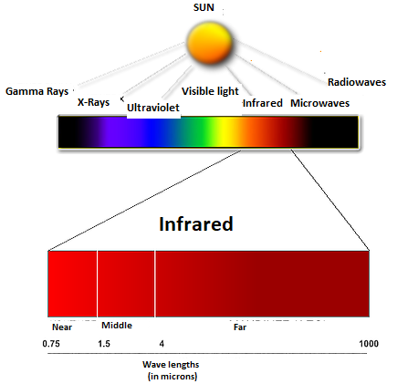

**1.3 How far away can I measure.**

You can aim the IR thermometer at small object such as an ant, but what you measure is an average temperature of the ant and the adjacent surface because of field of view of higher temperature is much larger than the ant. But, if a larger collection of ants occupies the whole FOV of the thermometer, then one can measure their average body temperature. This FOV is the main consideration to obtaining the correct temperature reading from IR thermometer. Many IRTs measures in the 8um to 15um wavelength band where the atmosphere is almost totally transparent.

Figure 1.3 Distance of sensation.

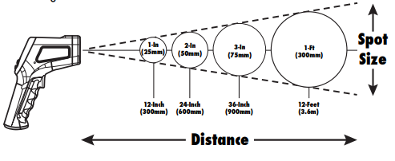

**CHAPTER 2**

**LITERATURE REVIEW**

**2.1 1884, The beginning.**

Stefan-Boltzmann's Law of black body radiation: In 1884, L.E. Boltzmann showed how Josef Stefan's empirical T4 Black Body Radiation Law, formulated in 1879, could be derived from the physical principles of thermodynamics. Boltzmann's findings were elegant, yet simple: Radiation Power = Temperature4 x Constant Consequently, Boltzmann has been named as the father of infrared thermometry. In infrared thermometers, a small CPU inside the device uses this formula to accurately predict the temperature of a target.

**2.2 1892, The disappearing-filament optical pyrometer.**

The earliest infrared thermometer (IRT) was known as the disappearing-filament optical pyrometer. The glowing brightness of a heated surface as a means for measuring temperature was first suggested by Becquerel in 1836, but it was not until 1892 that the French industrialist Le ChateLier introduced the first laboratory radiation thermometer.[1]

**2.3 1899, The first patent for disappearing-filament optical pyrometer.**

The first patent for the optical pyrometer was granted to Morse in 1899. Holborn and Kurlbaum, apparently unaware of the Morse patent, independently developed a similar disappearing-filament optical pyrometer in 1901. In Morse's improved apparatus some difficulties of previous optical pyrometer are overcome by so organizing the same as to permit a comparison based on the fact that if two substances are made to produce in the eye the same color effects or sensations and one of them, or a portion thereof is arranged in the path of the rays passing from the other to the eye the portion of the one so arranged or superposed will merge in the other and apparently be obliterated from view. The Leeds&Northrup Company acquired the Morse's patent of 1899 and in 1917 produced a commercially available disappearing-filament optical pyrometer similar to the one developed by Holburn and Kurlbaum. However, one of the main disadvantages of the disappearing-filament optical pyrometer (even till today) is its large size and need for an attendant for operation. They are still in use today because of their high degree of accuracy and useful functionality.

**2.4** **1931, Finally, a practical commercial product**

In addition to their accomplishments in 1917, the Leeds&Northrup Company introduced the first commercially-available total radiation thermometer.

**2.5** **1968, Emissivity altered**

The file date is 1968 July, it's still an analog; heavy device, with bulky shutter (or chopper), require long time to stabilized. this device uses the pyroelectric crystal as detector.

US3586439: DIRECT READING PYROMETER EMPLOYING PYROELECTRIC CRYSTAL DETECTOR

Country: United States of America

Inventor: Treharne, Richard W.; Xenia, OH

Assignee: Kettering Scientific Research, Inc.

**2.6 1977, Revolution of a sensor: the miniature thermopile**

It has been known that evaporating overlapping films of antimony and bismuth could form thermocouples. Since this construction is more rugged than that of the traditional thermopile, it became advantageous that this method be applied for the construction of thermopiles. This would lead to a significant development of the thermopile for space applications because of its small critical mass.

Overlapping areas that form the junction (hot) are fashioned on a thermally insulating layer set, or cold junction, in the middle of an aluminum block, which served as a heat sink. A reference junction is formed where the evaporated films come in contact with the aluminum block. Since the junctions have a very low specific heat, the time constant of an evaporated thermopile can be as short as 10 milliseconds. Furthermore, this evaporation technique allows the thermopile to be easily conformed to any size or shape.[2]

The first miniature infrared sensor, before this invention, the infrared sensor is as large as a coin.

Now, it can be smaller than a bean (4mm).

Title: US4111717: Small-size high-performance radiation thermopile

Inventor: Baxter, Ronald Dale; Furlong, PA

Assignee: Leeds & Northrup Company, North Wales, PA

**2.7 1984, 6,000,000pcs of Infrared Thermometer for ear**

In 1984, a major milestone occurred for infrared thermometers. IRT applications were soon found in the hospital, home, and ear! One of the turning point applications - the infrared ear thermometer - resulted in the sale of six million pieces, and consequently a substantial drop in the IRT's sensor cost.

This remarkable invention (USP4602642), has continued to evolve, and continues to thrive in the market today.

US4602642: Method and apparatus for measuring internal body temperature utilizing infrared emissions

Inventor: O'Hara, Gary J.; Escondido, CA ; Phillips, David B.; San Diego, CA

Assignee: Intelligent Medical Systems, Inc., Carlsbad, CA

**2.8 2002, The Most compact Infrared Thermometer**

In July 2002, ZyTemp introduced the world's smallest infrared thermometer (IRT), the TN105. The TN1 is as small as the battery of some of today's IRTs, and with it's anti-thermal shock capability, it can handily outperform traditional counterparts (You can put 2~4pcs into your shirt pocket.)

**2.9 2003, Infrared meets Thermocouple**

In July 2003, ZyTemp unveiled the TCT1, a low cost, high value infrared + thermocouple thermometer. In this design, non-contact and contact functionalities are conjoined to produce a dual utility of instant results (infrared) and high accuracy (thermocouple).

**CHAPTER 3**

## METHODOLOGY

Temperature is one of the most frequently measured parameters, and with good reason. Temperature serves as an important indicator of the condition of an object in machinery, medical diagnostics, quality control, etc.

There are many different methods for measuring temperature, including using infrared technology.

Infrared has been used successfully for many years in many fields, but infrared thermometry is a relatively new concept promising to reduce cost and increase reliability in temperature measurements across a wide variety of consumer and industrial applications.

**3.1 Principles of infrared thermometer.**

The underlying technology behind infrared thermometers is based on the principle that all objects emit radiation at wavelengths in the infrared region of the electromagnetic radiation spectrum.

Infrared is that portion of the electromagnetic spectrum that lies beyond the visible (blue to red, 0.4-0.75 um) response of the human eye. Because IR radiation is predominantly generated by heat, it is called thermal radiation.

From the it is clear that the curves never intersect, which implies that the radiation intensity at every wavelength is a strict function of the temperature. By measuring the intensity of the radiation, one can therefore determine the object’s temperature.

With rising temperature, the intensity at every wavelength of the radiation spectrum increases as well. This means that one can remotely determine the temperature of an object by measuring its radiated power.

If the temperature of an object increases, it will start to glow in a 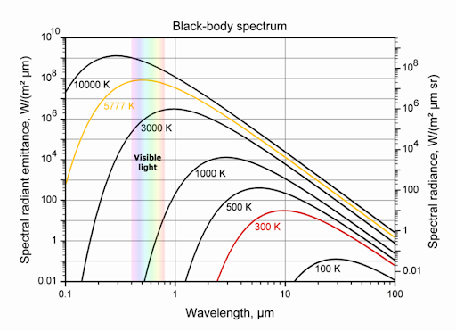dark red colour, with further increases in temperature changing the colour light to red, bright white, etc. 6000 K is the temperature of the sun and our eyes are adapted to “detect” this radiation as white light.

Figure 3.1 Radiation at different wavelength.

If the measured body has a temperature lower than 400 °C, one needs a radiation detector which is sensitive to a much longer wavelength than those of the visible spectrum. Such a detector must be sensitive to the infrared region (also called heat radiation) around 10 µm wavelengths. There are different sensors available which are capable for accurately detecting and measuring heat radiation in the 3 to 20 µm infrared (IR) wavelength region. Thermopile is a sensor used in IR thermometer to measure temperature through the IR radiation from body.

Thermopile measures the IR radiation and provides an output signal calibrated in a variety of ranges according to customer requirements. A thermopile sensor has an IR absorber connected with a series of thermocouples. The cold contacts of the thermocouples are connected to a known reference. These thermocouples measure the object temperature. The ambient temperature of the sensor is measured using a thermistor. Usually their output is in the range of a few microvolts.

**3.2 Infrared thermometer components.**

The infrared temperature sensor appears to be rather straightforward: point, press the button and read the temperature. However, measurement result will be quite disappointing without a through understanding of the instruments’ principle of operation and specification. Temperature measurement instruments can be

divided into contact and non-contact types. An infrared temperature sensor used in contact-type instruments include thermocouples, resistance temperature detectors (RTDs), thermistors, and semiconductor temperature sensors. Since contact sensors measures their own temperature they require physical contact with measured object to bring the sensor body to object’s temperature. In some applications, this contact creates problems: The measured object or media may be located at a distance or in a hazardous environment with no easy access. Measurements of moving objects are also difficult. A small object’s temperature may be altered when a relatively larger sensor touches it and act as a high sink. Non-contact infrared (IR) thermometers, if used properly, offer convenient solution for these and many other measurement applications. However, you should select the measuring instrument and measurement techniques to be compatible with the application.

Figure 3.2 Main components of infrared thermometer.

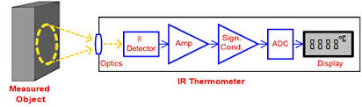

**3.2.1 IR thermometer.**

Infrared temperature sensor instrument design varies from simple hand-held thermometers that can be purchased for less than a hundred dollars to complex special-purpose instruments that cost hundreds and even thousands of dollars. However, some building blocks are common for most designs. A typical infrared thermometer consists of optical components, IR detector, electronics, and a display or interface output stage. Optical parts focus radiation energy onto the IR detector and filter out radiation outside the desired wavelength band. These components include collecting optics, lenses, fibre optics, and spectral optical filters.

**3.2.2 IR detector.**

The majority of IR detectors are either single-wavelength (also called single-color), or dual-wavelength (also called two colour) type. The single-wavelength detectors measure IR energy within a certain wavelength band, and the instrument calculates objects temperature based on the detector output and the Pre-set emissivity. Some thermometers have adjustable emissivity, and most simple units have fixed emissivity. Dual-wavelength detectors measure energy at two different wavelength bands, and the instrument calculates temperature based on the ratio of the two readings. If emissivity or the energy changes by the same amount at both bands, the measurement accuracy is not affected. Emissivity or the amount of radiated energy may change due to object change or movement, lens contamination or misalignment, or view obstruction. The dual-wavelength detector’s drawback is higher cost and lower accuracy under certain conditions.

The emissivity of many materials and surfaces remains relatively constant over the IR wavelength range, and measuring energy in any narrower band will be acceptable. Other materials have wavelength band will be acceptable. Other materials have wavelength bands with higher and lower emissivity due to high reflectivity or transmission and require narrow band detectors tuned to high emissivity wavelengths. To measure temperature of objects with emissivity that varies greatly over the IR wavelength spectrum and objects obscured by glass, smoke, steam, or other barriers, engineers need to use narrow band IR detectors. For example, short-wavelength detectors handle variable emissivity objects, lens contamination, and measurements through glass windows. Long-wavelength detectors are more prone to errors due to emissivity changes, but have a wide temperature range.

Photo detectors are built on a silicon substrate with an IR sensitive area that releases free electronics when impacted by the photons. The flow of electronics produces electrical signals proportional to the incident energy. These detectors are often used as arrays in thermal imaging systems.

**3.2.3 Amplifier.**

Amplifier is required to amplify the small signal coming from the sensor. Pyroelectric devices become electrically charged when their body temperature changes. To produce a usable signal, the incident IR energy has to “pulse”. The output peak-to-peak Ac signal is proportional to pulse energy. Since energy emitted by measured objects is usually steady, thermometers that use pyroelectric detectors have a mechanical or optical chopper in front of the sensor. These sensors are used in many home security systems.

Since all types of IR detectors produce signals in the microvolt range, a high-gain amplifier should follow the detector. Detector output v/s temperature curves are not linear and fluctuate greatly with a change in ambient temperature. To remedy this signal-conditioning circuit stabilizes the temperature and linearizes the signal. Many applications require an analog-to-digital converter converter (ADC)to convert the temperature reading to digital format.

**3.2.4 signal conditioning.**

While the ADC convertor is fundamental in converting any time varying analogue quantity to discrete values, ADCs are usually not designed for connecting directly to the acquisition sensor on their own. In this section, we discuss the components that typically exist between the sensor and the ADC. This stage will typically consist of amplification circuitry, filtering among other things. In the majority of cases the signal amplitudes produced by medical sensors are very small, often of the order of millivolts or smaller. Signals of these amplitudes are not usually compatible for direct connection to an ADC, which will likely have a maximum input range of the order of volts. By way of example, we want to consider the range of voltages that are typical of that produced by sensor. In this application a voltage range of approximately 2 V is typically observed. In this application a voltage range of approximately 2 V is typically observed. The ADC specification employs 8 bits in the input and a supply range between 0 and 5 V.

**CHAPTER 4:**

## ARCHITECTURES OF INFRARED THERMOMETER.

**4.1 Various functioning’s.**

In some cases, this is because the application itself literally destroys a contact-type sensor, such as when using a thermocouple or resistance temperature detector to measure molten metal. If the electrical interference is intense, such as in induction heating, the electromagnetic field surrounding the object will cause inaccurate results in conventional sensors. A remote infrared thermometer is immune to both problems. Non-contact infrared thermometers allow engineers to obtain accurate temperature measurements in applications where it is impossible or very difficult to use any other kind of temperature.

**4.1.1 Infrared thermocouples.**

An infrared thermocouple is an unpowered, low-cost infrared thermometer that measures surface temperature of materials without contact. It can be directly installed on conventional thermocouple controllers, transmitters and digital readout devices as if it were a replacement thermocouple. An infrared thermocouple can be installed in a fixed, permanent location, or used with a handheld probe.

Figure 4.3.1 Thermocouple.

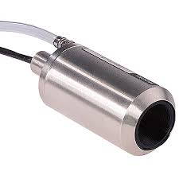

Because it is self-powered, it relies on the incoming infrared radiation to produce a signal via thermoelectric effects. Therefore, its output follows the rules of radiation thermal physics, and is subject to nonlinearities. But over a given range of temperatures, the output is sufficiently linear that the signal can be interchanged with a conventional thermocouple. Although each infrared thermocouple is designed to operate in a specific region, it can be used outside that region by calibrating the readout device accordingly.

### 4.1.2 Infrared camera terminologies.

|  |  |
| --- | --- |
| **Front View** | **Lens**- Detects infrared image  **Lens Cap**- Protects lens from dust and damage  **Focus Ring**-Used to make image clear  **Hand Strap**- Used to attach carrying strap |

|  |  |
| --- | --- |
| **Bottom View** | **Power Supply Port**- Top port (LCD screen up)  **USB/ RS-232 Port**- Middle port  **Video Port**- Bottom port (LCD screen up) |

### 

|  |  |
| --- | --- |
| **End View** | **Power Supply Port**- Top port (LCD screen up)  **USB/ RS-232 Port**- Middle port  **Video Port**-Bottom port (LCD screen up) |

**Top view.**

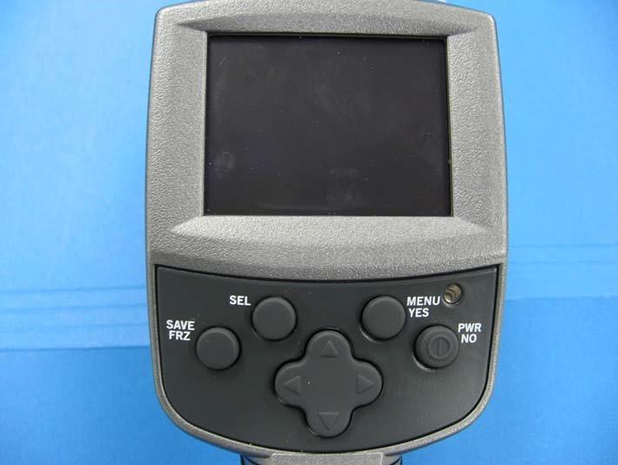

### 

**LCD screen**- Image and menu options appear here.

**SEL**- Press to auto adjust or switch between screen objects.

**SAVE/ FRZ**- Press briefly to freeze image or >1 second to save an image.

**Navigation Pad**-Used to move up/down and left/right.

**LED**-Indicates that power is on

**PWR/ NO**- Press to power on or to cancel selection in dialog box.

**MENU/ Yes**- Press to display vertical menu or to confirm selection in dialog boxes.

* 1. **Camera operations.**

## 4.2.1 Powering ON/OFF THERMACAM E45 camera.

## Pick up camera with right or left hand.

1. Press **PWR/NO** button (Figure 2.1). Screen display will resemble the figure.

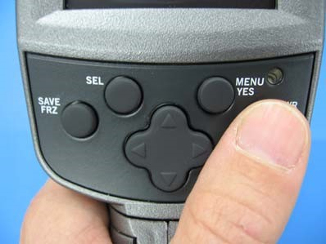 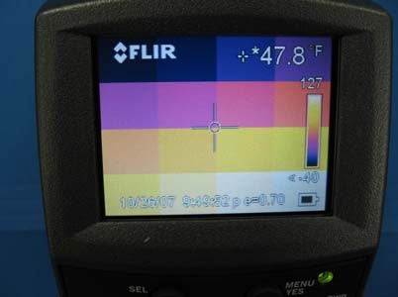

1. Remove **Lens Cap** (Figure 2.3- lens cap on, Figure 2.4 - lens cap removed).

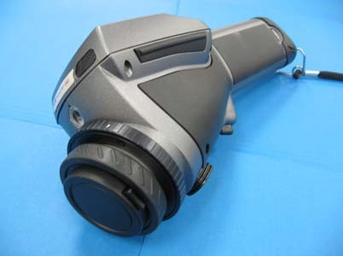 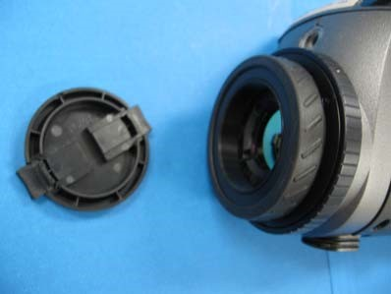

1. Press **PWR/NO** button (Figure 2.5) and hold > 2 seconds to **power off**. Screen will display “Shutting down in 2 seconds, 1 second, powering down”.

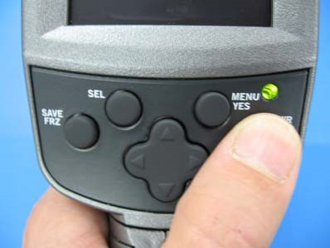 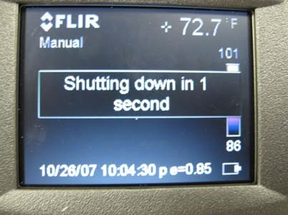

## 4.2.2 Setting emissivity.

## 

After powering on you must determine the emissivity value. There are tables that will give specific values for various materials and there are methods to determine the emissivity for each situation. However, for now use the default value of **0.85** and it should work fine.

1. Press **MENU/YES** button. Then menu opens.

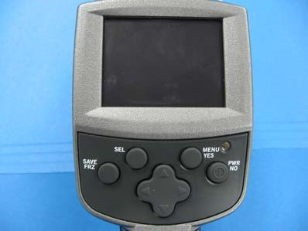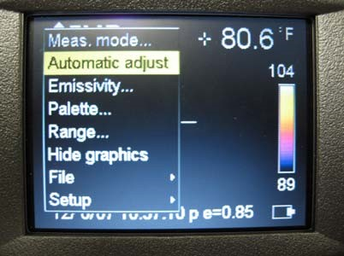

1. Press **Navigation Pad** **up/down** button to move down yellow highlight until “Emissivity” is highlighted.

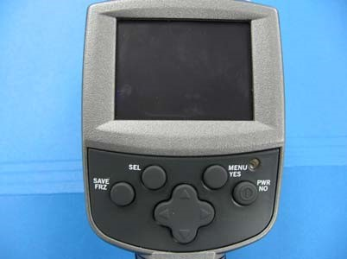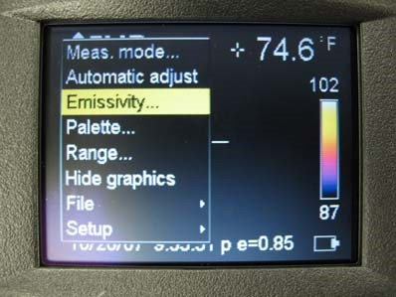

1. Press **MENU/YES** button. Emissivity value is highlighted.

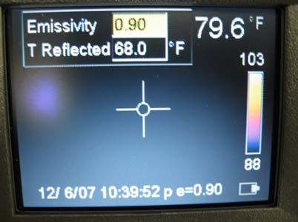

### Press Navigation Pad right/left button until 0.85 is achieved.

### 

**CHAPTER 5:**

**APPLYING IN CORONA VIRUS SCREENING.**

Early in 2020, news of a virus infecting people was discovered to be a type of **coronavirus**. The epicenter of the viral outbreak was in the city of Wuhan in Hubei province in China. There were concerns the viral infection is spreading, after reports that all regions in China have cases. The more serious concern is its likelihood of spreading after the Chinese Lunar New Year celebrations, in which millions of traveling Chinese could have been exposed to the virus. Soon, cases outside of China were reported. The world today is so highly interconnected, a contagion that can quickly spread diseases can lead to an epidemic as a worst case scenario. However, there are ways to prevent its spread in order to improve public safety. Since the most likely and common way for the virus to spread is through air travel, airports are becoming the checkpoints for screening passengers who have recently travelled to China. In the past, the screening process required a thorough check up of every individual regardless of whether they are sick or not. It can be a long and tedious process, so other techniques have been explored to make the process more effective and efficient.

Figure 5.0 Screening display.

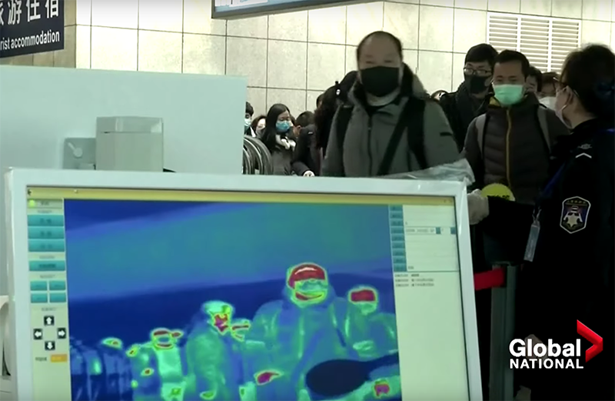

Using cameras and sensors provide the technology to help airports screen passengers more quickly. Using infrared sensors as heat scanners with camera systems, the presence of the virus won’t be confirmed, but it can detect whether the passenger is a risk. This is by detecting the body temperature in the passengers at the port of entry. Infrared sensors can sense body heat in humans and animals. With a visioning system that includes a camera and display, it can reveal information. If the sensor detects a passenger to have a high temperature, it will be a cause for concern.

**5.1 Detecting Body Heat.**

Infrared light is emitted from the human body in the form of heat. We cannot see it with the naked eye since it emits light at a different wavelength. On the electromagnetic spectrum, there is a wide range of frequencies from low frequency radio waves to high frequency gamma rays. The part of the spectrum that we can see falls under visible light. In theory, the more heat a body radiates the more infrared light can be detected.

It is for this reason that infrared sensors are used for heat scanners. The sensors detect the amount of heat being emitted by its colour. The colour is actually not how it would appear in visible light, but more for the purpose of identifying the temperature of the body. Computer algorithms are used to generate a colour palette that represents the scale in temperature. For example, the higher temperatures can be highlighted with a different colour palette compared to lower temperatures. Developers create a colour palette for normal temperature below 36–37° Centigrade (98–100° Fahrenheit). For temperatures above 37° Centigrade, having a different colour will alert screeners.

When applied for passenger screening at airports, those with a body temperature higher than 37° Centigrade could appear in colour RED. This will allow screeners to separate those passengers for further examination by medical professionals. This isolates those at higher risk from everybody else much quicker than having screeners use thermometers for each and every passenger.

Figure 5.1.1 Thermographic Diagram.

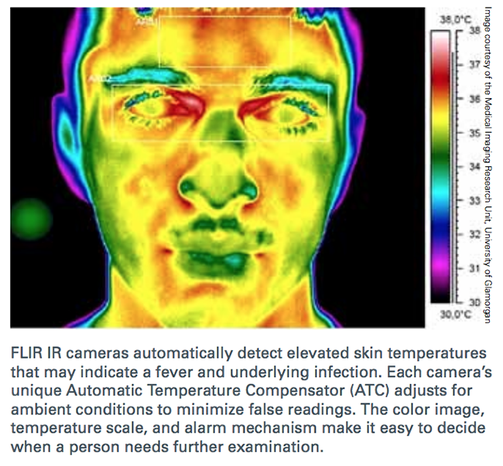

**5.2 Thermal imaging.**

Thermal images generated from thermographic cameras, are also called thermograms. They display the amount of infrared energy emitted, transmitted, and reflected by an object. This can be represented by the **Incident Radiant Power**, which relates the emitted, transmitted and reflected radiation.

**IRP = Incident Radiant Power**  
**ERP = Emitted Radiant Power**

**TRP = Transmitted Radiant Power**

**RRP = Reflected Radiant Power**

IRP = ERP + TRP + RRP

In thermal imaging, the sensor needs to detect the emissivity, or the amount of infrared radiation an object or body emits. The image is captured in infrared light and then converted to a human viewable format (usually in JPEG). This shows the image pixel by pixel, so it will show the regions where there is a high amount of radiation. This can be interpreted as a high temperature in the body or the presence of fever.

**5.3 Use at Airports.**

Since the Ebola and SARS outbreak, airports around the world have adopted stricter policies for screening. Not all airports use heat scanners on a daily basis, but when there are health emergencies like virus outbreaks, thermographic cameras are an effective tool. They have been found to be safe to use, as they do not emit any hazardous radiation that can affect human health. Screening a passenger can also be assisted by analysis software that use of AI, providing a way to help screeners identify at risk passengers.

Thermographic cameras do not detect the presence of the virus. They just detect high temperatures in passengers which show signs of fever or other medical condition which can be further examined. Fevers are an indication of a viral infection, and it is good to detect this. That can significantly help screeners prevent the entry of high-risk passengers who can affect the general population.

Since these systems are contactless, it also reduces the risk for screeners to contract the virus. This allows screeners to focus on identifying high risk passengers who are then referred to medical professionals on standby for further examination. This has proven to be an effective way of screening that provides a high level of safety.

**CHAPTER 6:**

**APPLICATIONS**

• Heating and air conditioning – Detection insulation breakdown, heat loss and gain and furnace and duct leakage.

• Industrial/Electrical – Monitoring motor/engine cooling system performance, boiler operations, steam systems and detection of hot spots in electrical system and panels.

• Food safety – checking equipment performance, sanitation and process temperature conditions, and scanning refrigerated display cases, trucks, storage areas and cooling system.

• Agriculture – Monitoring plant temperature for stress and animal bedding to detect spoiling.

**CHAPTER 7:**

**ADVANTAGES**

• Economically priced for distance readings up to 20 feet.

• Large, easy-to-read LCD allows rapid, multiple readings.

• Measure temperatures up to 626°F(330°C).

• Quick temperature measurement from less than 12 inches—take readings of any liquid, solid, or semisolid in less than one second.

• Our most economical units.

• Models small enough to fit in a shirt pocket.

• Non-contactable process.

• Log several readings per second instead of waiting several minutes for a single reading from a contact thermometer.

• Distance-to-sight ratio of up to 60 to 1

**CHAPTER 8:**

## CONSTRAINTS

Remember that IR temperature measurements are determining temperature using radiation and not via direct contact with a solid(conduction) or by being submerged in a fluid(convection). As a result, three glaring potential technical challenges present themselves:

1- The requirement of line-of-sight for measuring.

2-The attenuation of your desired signal or introduction of noise from other radiant sources.

3-The need for an accurate value of the emissivity of your subject.

You may not touch your object to measure its temperature, but you need a clear (and materials that are transparent in visible light are rarely transparent to IR), unobscured, and noise-free view of the object to measure its temperature using IR. Further, you need to know a good deal about what the object is made of in order to determine the emissivity of it (no real materials ae true blackbodies).

**CHAPTER 9:**

## SUMMARY

DeltaTrak reports the new model 15004 Non-contact Forehead Infrared Thermometer serves as a valuable solution in the fight against the coronavirus. One of the first steps in preventing cross-contamination is to measure and screen personnel that may have a fever, which is one of the main symptoms of COVID-19. The need to screen individuals that work together in large workforce environments is imperative to reduce the risk of spreading the infection. The new FDA and CE approved Forehead Infrared Thermometer provides instant readings without necessary contact making it an ideal COVID-19 risk prevention solution.

With so much concern about the health and safety at this time, it was important that we provided a solution that can be used to quickly and safely measure body temperature in large group settings, aid Frederick WU, President and CEO of DeltaTrak, our focus is presenting meaningful solutions to current pandemic conditions for business we serve around the world. We believe that this new non-contact forehead infrared thermometer will be significantly beneficial in performing the daily preventive protection measures that we must do to minimise cross-contamination and maximise safety for all of us in every community during this trying time.

**CHAPTER 10:**

## CONCLUSION

Infrared thermography is a fast, clean and safe technology that is used in a wide variety of applications. This paper has reviewed the use of infrared thermography in two very important fields: temperature measurement and non-destructive testing. The principles and essential theoretical background in these two fields have been reviewed. This background information is provided to help the dissemination of these technologies and to assist beginners in a better understanding of the subject. Moreover, recent work on these topics has been reviewed and discussed.

Infrared thermography has experienced a great evolution in a relatively short time. Important improvements were achieved in different fields. However, there is a variety of limitations that need to be taken into account. Infrared thermography is highly dependent on the sensor selection and the experimental setup. It may be affected by the instrument and by the environment. These problems can be minimized, but only with adequate setup and testing procedures, which mostly depend on the operator’s skill.

Infrared thermography is a mature technique for non-destructive testing. Recent advances in this field allow this technology to detect many types of defects. However, a defect can only be detected using infrared thermography if it opposes enough thermal resistance to create visible thermal contrast. Future sensors with improved sensibility are required to improve the general applicability of this technique. Further work is also required in signal and image processing on the acquired infrared thermal images in order to enhance the detection, to simplify the interpretation of the results and to reduce human interference.

Nowadays, infrared sensors are present in many different fields, but their use is still not widespread. This is partially due to the cost and also due to lack of adequate training. However, fast and affordable hardware developed recently indicates that many other fields will take advantage of the use of infrared thermography in the near future, integrating inexpensive infrared sensors in our daily life.

### INFRARED THERMOGRAPHY.

## REFERENCES

1. Maldague, X. Theory and Practise of Infrared Technology for Non-destructive Testing; Wiley: New York, NY, USA, 2001.

2. Vollmer, M; Mollmann, K.P.” Infrared Technology for Non-destructive Testing; Wiley: New York, NY, USA,2001.

3. Vollmer, M; Mollmann, K.P.” Infrared Thermal Imaging: Fundamentals, Research and Applications: Wiley: Weinheim, Germany,2011.

4. Zissis, G.J.; Wolfe, W.L. Infrared Handbook. Technical report, DTIC document, 1978.

5.Meola, C. Infrared Thermography: Recent Advances and Future Trends; Bentham Science.

6. Jones. B.F. A reappraisal of the use of infrared thermal image analysis in medicine. IEEE Trans Med. Imaging 1998, 17, 1019-1027.

7. Howell, J.R.; Siegel, R.; Menguc, M.P Thermal Radiation Heat Transfer, 5th ed.; Taylor and Francis: New York, NY, USA,2010.

8. Duxbury, G. Fundamentals of Infrared Detector Operation and Testing. J. Mod. Opt. 1992,39,190-190.

9. Herve, P.; Cedelle, J.; Negreanu, I. Infrared Technique for simultaneous determination of temperature and emissivity. Infrared Phys. Technol.2012,55,1-10.

10. Luhmann, T.; Piechel, J.; Roelfs, T. Geometric Calibration of Thermographic Cameras. In Thermal Infrared Remote Sensing; Springer: Berlin/Heidelberg, Germany, 2013; pp. 27-42.

11. Maldague, X. Applications of infrared thermography in non-destructive evaluation. Trends Opt. Nondestruc. Test. 2000, pp.591-609.

12. Netzelmann, U., Walle, G. induction thermography as a tool for reliable detection of surface defects in forged components. In proceedings of 17th World Conference on Non-destructive Testing, Shanghai, china, 25-28 October 2008; pp.1-8.

13. [ww.news18](http://www.news18).com